**Lab 10**

**1.WAP to simulate the following contiguous memory allocation technique:**

1. **Worst-fit b. Best-fit c. First-fit**
2. **Memory Allocation (Worst fit)**

**Code:**

#include<stdio.h>

#include<conio.h>

#define max 25

int main()

{

int frag[max],b[max],f[max],i,j,nb,nf,temp; static int bf[max],ff[max];

printf("\n\tMemory Management Scheme - Worst Fit");

printf("\nEnter the number of blocks:");

scanf("%d",&nb);

printf("Enter the number of files:");

scanf("%d",&nf);

printf("\nEnter the size of the blocks:-\n");

for(i=1;i<=nb;i++)

{

printf("Block %d:",i);

scanf("%d",&b[i]);

}

printf("Enter the size of the files :-\n");

for(i=1;i<=nf;i++)

{

printf("File %d:",i);

scanf("%d",&f[i]);

}

for(i=1;i<=nf;i++)

{

for(j=1;j<=nb;j++)

{

if(bf[j]!=1)

{

temp=b[j]-f[i];

if(temp>=0)

{

ff[i]=j;

break;

}

}

}

frag[i]=temp;

bf[ff[i]]=1;

}

printf("\nFile_no:\tFile_size :\tBlock_no:\tBlock_size:\tFragement");

for(i=1;i<=nf;i++)

printf("\n%d\t\t%d\t\t%d\t\t%d\t\t%d",i,f[i],ff[i],b[ff[i]],frag[i]);

}

**Output:**

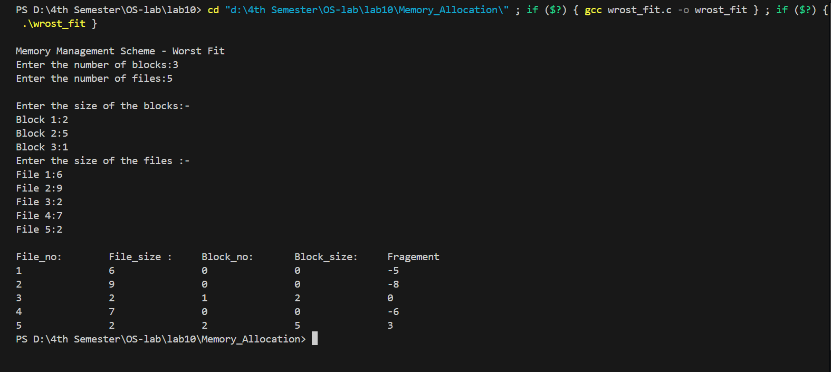

**Memory Allocation (Best fit)**

**Code:**

#include<stdio.h>

#include<conio.h>

#define max 25

int main()

{

int frag[max],b[max],f[max],i,j,nb,nf,temp,lowest=10000;

static int bf[max],ff[max];

printf("\n\tMemory Management Scheme - Best Fit");

printf("\nEnter the number of blocks:");

scanf("%d",&nb);

printf("Enter the number of files:");

scanf("%d",&nf);

printf("\nEnter the size of the blocks:-\n");

for(i=1;i<=nb;i++)

{

printf("Block %d:",i);

scanf("%d",&b[i]);

}

printf("Enter the size of the files :-\n");

for(i=1;i<=nf;i++)

{

printf("File %d:",i);

scanf("%d",&f[i]);

}

for(i=1;i<=nf;i++)

{

for(j=1;j<=nb;j++)

{

if(bf[j]!=1)

{

temp=b[j]-f[i];

if(temp>=0)

if(lowest>temp)

{

ff[i]=j;

lowest=temp;

}

}}

frag[i]=lowest; bf[ff[i]]=1; lowest=10000;

}

printf("\nFile No\tFile Size \tBlock No\tBlockSize\tFragment");

for(i=1;i<=nf && ff[i]!=0;i++)

printf("\n%d\t\t%d\t\t%d\t\t%d\t\t%d",i,f[i],ff[i],b[ff[i]],frag[i]);

}

**Output:**

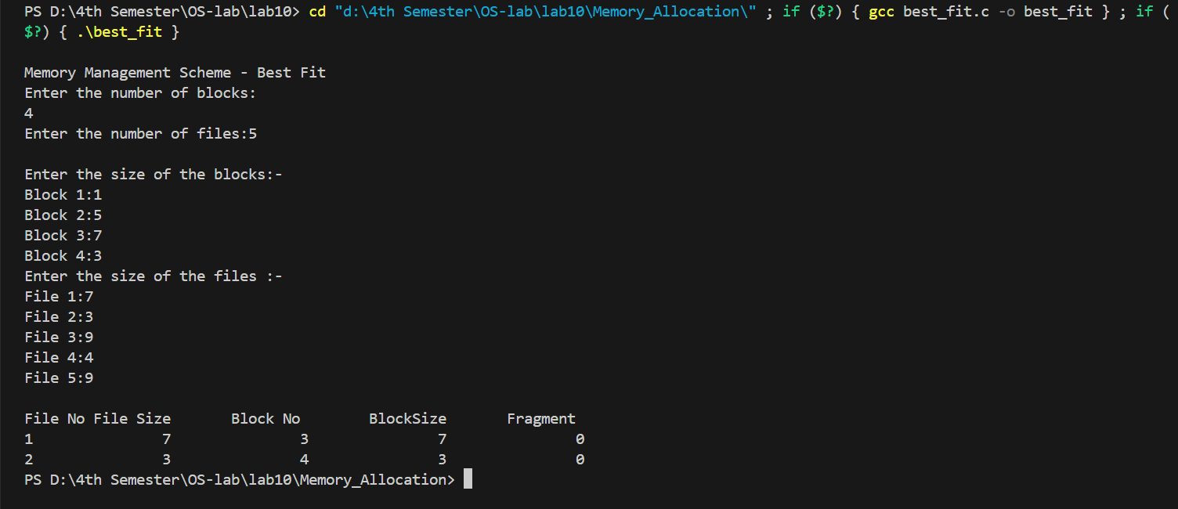

**Memory Allocation (First fit)**

**Code:**

#include<stdio.h>

#include<conio.h>

int main()

{

int bsize[10], psize[10], bno, pno, flags[10], allocation[10], i, j;

for(i = 0; i < 10; i++)

{

flags[i] = 0;

allocation[i] = -1;

}

printf("Enter no. of blocks: ");

scanf("%d", &bno);

printf("\nEnter size of each block: ");

for(i = 0; i < bno; i++)

scanf("%d", &bsize[i]);

printf("\nEnter no. of processes: ");

scanf("%d", &pno);

printf("\nEnter size of each process: ");

for(i = 0; i < pno; i++)

scanf("%d", &psize[i]);

for(i = 0; i < pno; i++) //allocation as per first fit

for(j = 0; j < bno; j++)

if(flags[j] == 0 && bsize[j] >= psize[i])

{

allocation[j] = i;

flags[j] = 1;

break;

}

//display allocation details

printf("\nBlock no.\tsize\t\tprocess no.\t\tsize");

for(i = 0; i < bno; i++)

{

printf("\n%d\t\t%d\t\t", i+1, bsize[i]);

if(flags[i] == 1)

printf("%d\t\t\t%d",allocation[i]+1,psize[allocation[i]]);

else

printf("Not allocated");

}

}

**Output:**

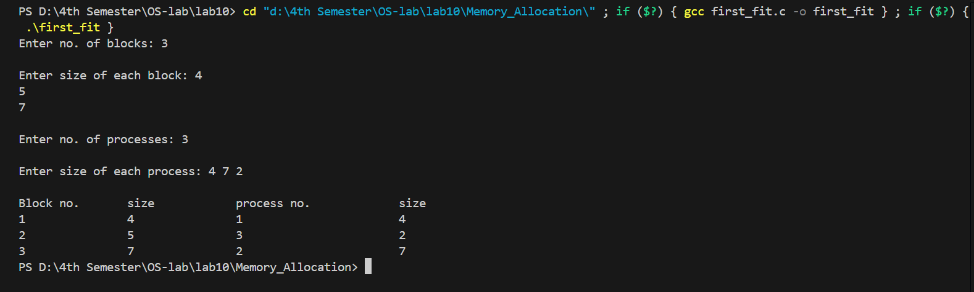

**2. WAP to implement sequential file allocation technique.**

**Code:**

// C program to implement sequential file allocation method

#include<stdio.h>

#include<conio.h>

int main()

{

int f[50], i, st, len, j, c, k, count = 0;

for(i=0;i<50;i++)

f[i]=0;

printf("Files Allocated are : \n");

begin:

printf("\n Enter the starting block and lenght of file:");

scanf("%d%d", &st,&len);

for(k=st;k<(st+len);k++)

if(f[k]==0)

count++;

if(len==count)

{

for(j=st;j<(st+len);j++)

if(f[j]==0)

{

f[j]=1;

printf("%d\t%d\n",j,f[j]);

}

if(j!=(st+len-1))

printf("The file is allocated to disk\n");

}

else

printf(" The file is not allocated \n");

printf("Do you want to enter more file(Yes - 1/No - 0)");

scanf("%d", &c);

if(c==1)

goto begin;

return 0;

}

**Output:**

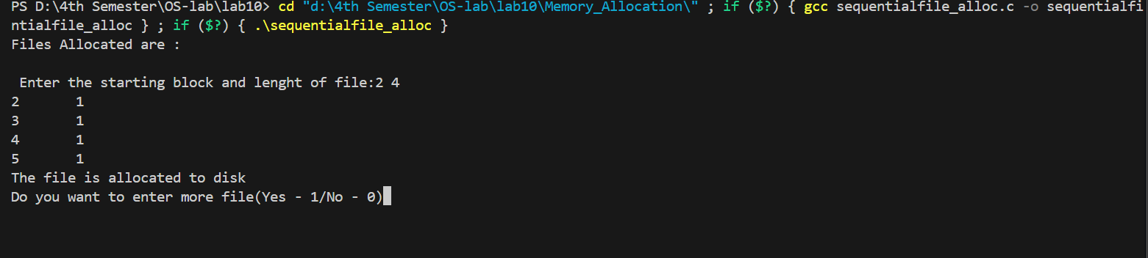

**3. WAP to implement linked list file allocation technique.**

**Sample code:**

// C code to implement linked file allocation technique

#include<stdio.h>

#include<conio.h>

#include<stdlib.h>

int main()

{

int f[50], p,i, st, len, j, c, k, a;

for(i=0;i<50;i++)

f[i]=0;

printf("Enter how many blocks already allocated: ");

scanf("%d",&p);

printf("Enter blocks already allocated: ");

for(i=0;i<p;i++)

{

scanf("%d",&a);

f[a]=1;

}

x: printf("Enter index starting block and length: ");

scanf("%d%d", &st,&len);

k=len;

if(f[st]==0)

{

for(j=st;j<(st+k);j++)

{

if(f[j]==0)

{

f[j]=1;

printf("%d-------->%d\n",j,f[j]);

}

else

{

printf("%d Block is already allocated \n",j);

k++;

}

}

}

else

printf("%d starting block is already allocated \n",st);

printf("Do you want to enter more file(Yes - 1/No - 0)");

scanf("%d", &c);

if(c==1)

goto x;

else

exit(0);

}

**Output:**

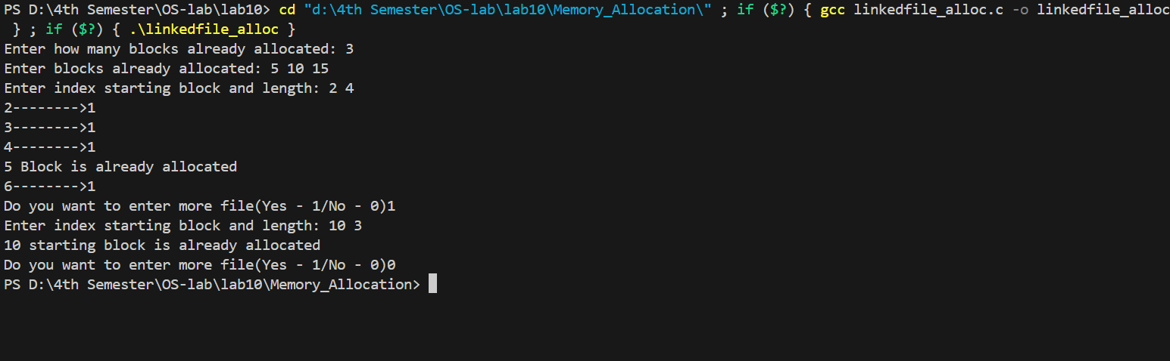

1. **WAP to implement single level directory.**

**code:**

//C program to simulate single level directory

#include<stdio.h>

#include<conio.h>

#include<string.h>

int main()

{

int nf=0,i=0,j=0,ch;

char mdname[10],fname[10][10],name[10];

printf("Enter the directory name:");

scanf("%s",mdname);

printf("Enter the number of files:");

scanf("%d",&nf);

do

{

printf("Enter file name to be created:");

scanf("%s",name);

for(i=0;i<nf;i++)

{

if(!strcmp(name,fname[i]))

break;

}

if(i==nf)

{

strcpy(fname[j++],name);

nf++;

}

else

printf("There is already %s\n",name);

printf("Do you want to enter another file(yes - 1 or no - 0):");

scanf("%d",&ch);

}

while(ch==1);

printf("Directory name is:%s\n",mdname);

printf("Files names are:");

for(i=0;i<j;i++)

printf("\n%s",fname[i]);

}

**Output:**

